# Round 1 -Tool Used: Gemini (text/image), StoryAI (video)

### Text

1. Prompt: “Explain what Digital Wallets are? give some advantages and disadvantages”

Output:

A digital wallet is essentially a mobile app that securely stores your credit cards, debit cards, loyalty cards, and even cash (depending on the provider) for easy access and contactless payments. They can be used with smartphones and other devices to pay in stores, online, and send or receive money.

Here's a breakdown of some of the advantages and disadvantages of digital wallets:

Advantages:

Convenience: No more bulky wallets or digging for the right card. Everything is stored securely in your phone.

Security: Digital wallets often use strong encryption and fingerprint or PIN verification to protect your financial information. In some cases, they may even be more secure than physical cards, since a lost phone can be locked or wiped clean remotely.

Tracking and Budgeting: Many digital wallets track your spending and categorize transactions, which can help you stay on top of your finances.

Rewards: Some wallets offer loyalty programs and cashback rewards for using their platform.

Disadvantages:

Limited Acceptance: While digital wallets are becoming more widely accepted, they may not be an option everywhere, especially in remote areas or internationally.

Tech Reliance: If your phone dies, is lost, or stolen, you could lose access to your wallet.

Security Concerns: While digital wallets can be secure, there's always a risk of hacking or malware. It's important to choose a reputable provider and practice good security habits.

Overall, digital wallets offer a convenient and secure way to make payments and manage your finances. However, it's important to weigh the advantages and disadvantages to decide if they're right for you.

Narration: This is a good explanation but it comes out in bullet points, I am going to try and get a response in paragraph format.

1. Prompt: “Explain what Digital Wallets are? give some advantages and disadvantages. Write it in paragraph format, with at least 2 paragraphs for each.”

Output:

Digital wallets are revolutionizing the way we carry and use our financial tools. Imagine a slim app on your phone that replaces your bulky wallet, holding everything from credit cards and loyalty programs to cash (depending on the provider). This app allows for secure contactless payments in stores, online transactions, and even sending or receiving money with ease.

The convenience factor is undeniable. No more rummaging through your bag for the right card – with a digital wallet, everything is accessible in a few taps on your phone. Security is another major perk. Digital wallets often use advanced encryption technology and require fingerprint or PIN verification for added protection. In fact, they can be even more secure than physical cards. If you lose your phone, it can be remotely locked or wiped clean, minimizing the risk of unauthorized access. Furthermore, some digital wallets offer budgeting and expense tracking features. Transactions are automatically categorized, giving you valuable insights into your spending habits and helping you stay on top of your finances. Additionally, some wallets integrate loyalty programs and reward users with cashback for using their platform.

However, digital wallets aren't without their drawbacks. While their adoption is growing rapidly, they might not be universally accepted, especially in remote locations or internationally. This can be a concern for frequent travelers who rely on their cards for backup. Another potential hurdle is our dependence on technology. A dead phone battery, a lost device, or even a stolen one can leave you without access to your wallet. While some services offer temporary solutions, it can be a major inconvenience. Security is also a double-edged sword. While digital wallets offer strong safeguards, there's always a risk of cyberattacks or malware. Choosing a reputable provider with a proven security track record and practicing good cyber hygiene are crucial to minimizing these risks. Ultimately, digital wallets present a wealth of advantages for those who prioritize convenience and security. However, it's important to consider the potential limitations and take steps to mitigate any security concerns before making the switch.

Narration: This is a better response, but it did not give the number of paragraphs I wanted!

1. Prompt: “Explain what Digital Wallets are in two paragraphs. Give some advantages of digital wallets in two paragraphs and disadvantages of digital wallets in two paragraphs.”

Output:

Digital wallets are like having a slim and secure version of your traditional wallet on your phone. They store your credit cards, debit cards, loyalty programs, and even cash (depending on the provider) all in one place. You can use them to make contactless payments in stores, pay online, and even send or receive money with just a few taps on your phone. This eliminates the need to carry around a bulky wallet and fumble for the right card at checkout.

Digital wallets offer several advantages. First, they are incredibly convenient. Everything you need for your purchases is readily accessible on your phone, saving you time and frustration. Security is another major benefit. Digital wallets typically use strong encryption and require fingerprint or PIN verification to access your financial information. This can be even more secure than physical cards, as a lost phone can be remotely locked or wiped clean to prevent unauthorized access. Some wallets even go a step further by offering budgeting and expense tracking features, helping you manage your finances more effectively.

Despite their advantages, digital wallets do come with some drawbacks. One potential limitation is acceptance. While their popularity is on the rise, they might not be accepted everywhere, particularly in remote areas or when traveling internationally. This can be a concern for people who rely on physical cards as a backup. Additionally, digital wallets require a working smartphone. A dead battery, a lost device, or even a stolen phone can leave you without access to your wallet. While some services offer temporary solutions, it can be a major inconvenience. There's also a security concern, although these wallets use strong encryption. Cyberattacks and malware are still a possibility. Choosing a reputable provider with a good security track record and practicing good cyber hygiene are essential for minimizing these risks.

Narration: Again, this did not meet the paragraph requirement but gave good information

Review and Rating: I would rate this a **4/5** since it did a really good job of giving all the necessary information, but it did not meet the formatting and size requirement.

## Image

1. Prompt: “Make an image that represents Digital wallets”

Narration: these are very general images, they do represent digital wallets but I was looking for an example of digital wallet (software/ platform).

1. Prompt: “Make an image that represents Digital wallet software”

Narration: these images were even further than what I was looking for.

1. Prompt: “Make an image that shows how a Digital wallet platform would look like on a phone”

Narration: This does a much better job of representing digital wallets!

Review and Rating: I would rate this a **3/5** since it provided good images for the most part but didn’t deliver on the exact requirement.

## Video

1. Prompt: “make a video explaining what digital wallets are”

Output: <https://drive.google.com/file/d/1fJMMoYVgF-TOp4uuCWxuaqCG4ZBPFD7s/view?usp=sharing>

Narration: This video took very long to generate and therefore StoryAI is not an applicable tool for this assignment since it cannot generate two more videos within the hour.

Review and Rating: I would rate this a **3/5.** This tool made good videos but took very long to generate (this is normal for videos). This tool only makes videos as part of a story so it is not really good for generating an informative video, but really good at generating stories.

# Round 2 - Tool Used: ChatGPT (Text), Copilot (Image), and Runway (Video)

### Text

1. Prompt: “Explain what Digital Wallets are? give some advantages and disadvantages”

Output:

Digital wallets, also known as e-wallets or mobile wallets, are electronic devices or online services that enable individuals to make electronic transactions. They securely store users' payment information, such as credit card details, bank account information, and other relevant data, to facilitate online and in-store purchases. Digital wallets can be accessed through various devices, including smartphones, tablets, and computers.

Advantages of Digital Wallets:

Convenience: Digital wallets allow users to make transactions quickly and conveniently, eliminating the need to carry physical cash or cards.

Security: They often use encryption and other security measures to protect users' financial information, reducing the risk of fraud and identity theft compared to traditional payment methods.

Accessibility: Users can access their digital wallets anytime, anywhere, as long as they have an internet connection, making it easy to make purchases or send money remotely.

Organized Expense Tracking: Digital wallets often provide features for tracking expenses and managing budgets, helping users monitor their spending habits more effectively.

Loyalty Programs and Rewards: Many digital wallet providers offer incentives such as cashback, discounts, or loyalty points for using their services, providing additional value to users.

Disadvantages of Digital Wallets:

Dependency on Technology: Digital wallets rely on technology, such as smartphones or internet connectivity, which can be prone to malfunctions or outages. Users may face difficulties in making transactions during such situations.

Security Concerns: While digital wallets employ security measures, they are not immune to cyber threats such as hacking and malware attacks. If a user's digital wallet is compromised, it can lead to financial losses and privacy breaches.

Compatibility Issues: Not all merchants accept digital wallet payments, and compatibility can vary depending on the region and the type of digital wallet. Users may encounter limitations in using their preferred digital wallet for certain transactions.

Potential Fees: Some digital wallet providers may charge fees for certain transactions, such as currency conversion fees or withdrawal charges, which can increase the cost of using the service.

Limited Adoption: Despite their growing popularity, digital wallets may not be widely adopted in certain regions or among certain demographics, limiting their usefulness in those contexts.

Overall, while digital wallets offer numerous benefits in terms of convenience and security, users should also be aware of potential drawbacks and exercise caution when using these services.

Narration: Really good information with all necessary and requested information. Organized in bullet points.

1. Prompt: “Explain what Digital Wallets are in two paragraphs. Give some advantages of digital wallets in two paragraphs and disadvantages of digital wallets in two paragraphs. For a total of 6 paragraphs”

Output:

Digital wallets, also known as e-wallets or mobile wallets, are digital platforms that securely store users' payment information, such as credit card details, bank account information, and other relevant data. Essentially, they serve as electronic alternatives to traditional physical wallets, enabling users to make transactions both online and in-person without the need to carry physical cash or cards. Digital wallets can be accessed through various devices like smartphones, tablets, and computers, providing users with a convenient and efficient means of managing their finances. These platforms typically utilize encryption and other security measures to safeguard users' financial data, thereby reducing the risk of fraud and identity theft compared to conventional payment methods. Furthermore, digital wallets often offer features for organizing expenses, tracking spending habits, and accessing loyalty programs, enhancing their utility and value for users.

Digital wallets offer several advantages that contribute to their increasing popularity among consumers. Firstly, they provide unparalleled convenience, allowing users to make transactions quickly and effortlessly from anywhere with an internet connection. Whether it's paying for groceries at a store or splitting a bill with friends at a restaurant, digital wallets streamline the payment process, saving time and effort. Moreover, digital wallets enhance security by minimizing the need to carry physical cards or cash, thus reducing the risk of loss or theft. With features like biometric authentication and tokenization, these platforms offer robust protection against unauthorized access and fraudulent activities, instilling confidence in users about the safety of their transactions.

However, digital wallets also come with certain disadvantages and challenges. One significant drawback is the dependency on technology, as digital wallets rely on internet connectivity and device functionality. Users may encounter difficulties in making transactions during instances of network outages or device malfunctions, limiting their accessibility and reliability. Additionally, while digital wallets offer enhanced security features, they are not entirely immune to cyber threats. Despite employing encryption and authentication mechanisms, hackers may still attempt to compromise users' digital wallets through various means, posing a risk of financial losses and privacy breaches. Furthermore, compatibility issues can arise, as not all merchants accept digital wallet payments, and the availability of certain digital wallet services may vary depending on the region. Users may experience limitations in using their preferred digital wallet for certain transactions, impacting their overall convenience and utility. Despite these challenges, ongoing advancements in technology and security measures continue to improve the functionality and reliability of digital wallets, driving their adoption and usage worldwide.

Narration: For whatever reason, this AI won’t meet my paragraph requirement, but overall it gave good information.

1. Prompt: “That (the above prompt/response) is great, now write HTML Code for so I can add it to my website”

Output:

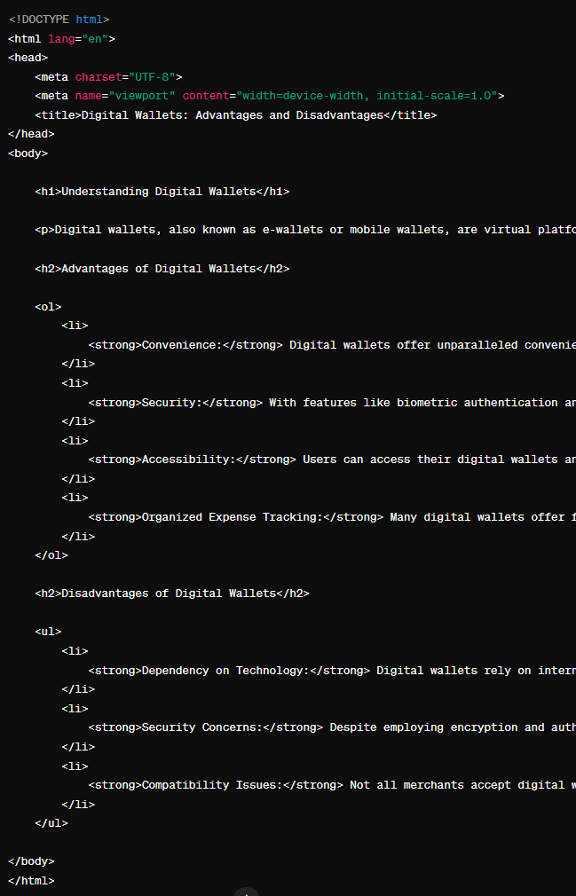

Narration:

Review and Rating: I would rate this a **4/5** since it did a really good job of giving all the necessary information, but it did not meet the formatting and size requirement. It also did a good job of converting text into HTML to incorporate in our website

## Image

1. Prompt: “Generate a word cloud for digital wallet.”

Output: 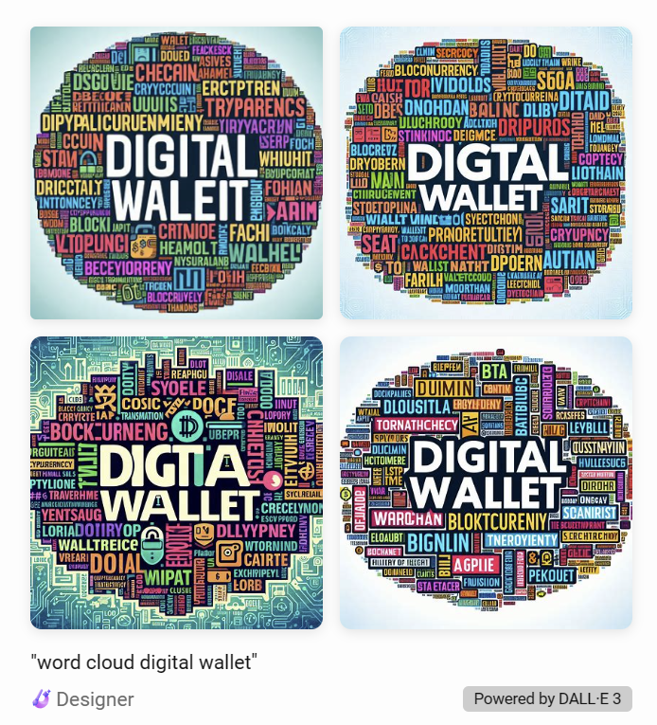

Narration: The AI tool successfully created a word cloud, but the words are not grammatically correct English.

1. Prompt: “What is the symbol for digital wallet?”

Output: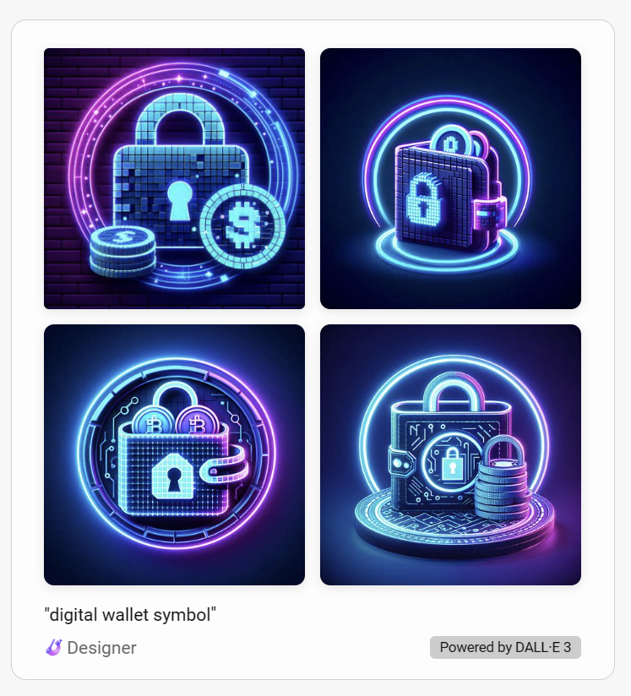

Narration: The images successfully described some of the natures of digital wallet.

1. Prompt: "Visualize the convenience and security of a digital wallet in everyday transactions."

Output: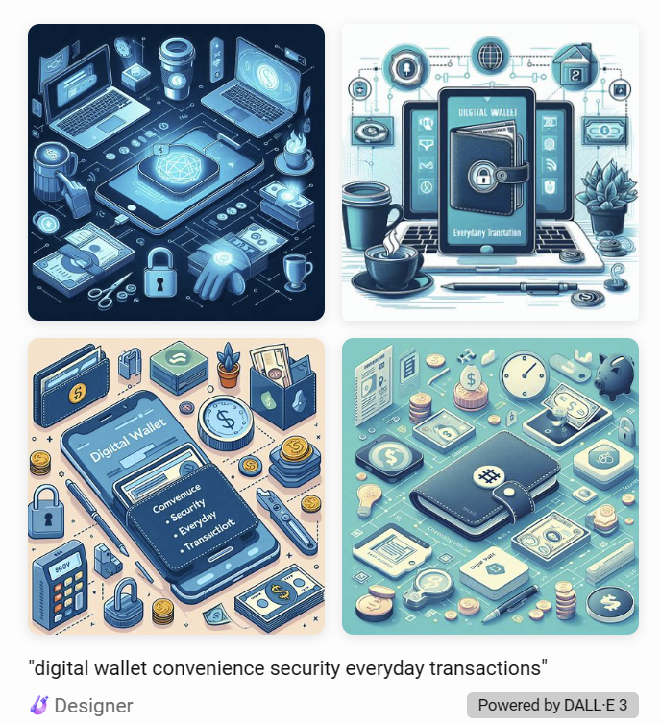

Narration: the images somehow described the “security” aspect, but not the “convenience” aspect.

Review and Rating: I would rate this a **3/5,** The images look nice, but they lack accuracy; more detailed prompts are needed.

## Video

1. Prompt: “make a 5 second ad for a digital wallet app”

Output: 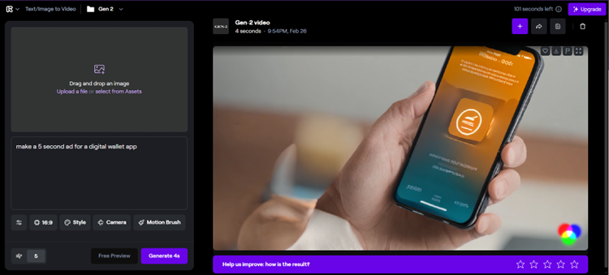

Narration: unable to download the video without having to pay first. This tool only make short clips (about 5 seconds). The video is pretty much a distorted image which is moving slightly. It is closer to being a live image than a video.

1. Prompt: “make a video of crypto currency on digital wallet app”

Output: 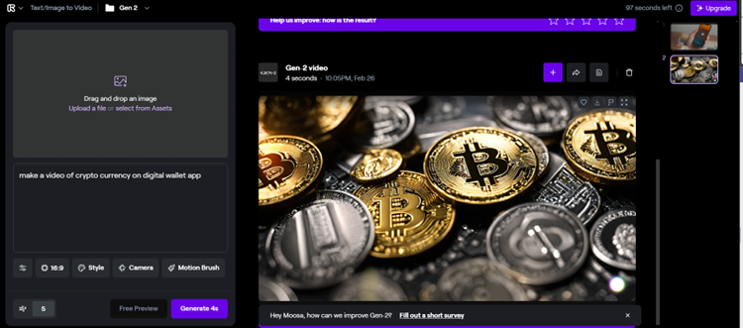

Narration: It seems this app only makes live images not videos

1. Prompt: “a person using digital wallet”

Output: 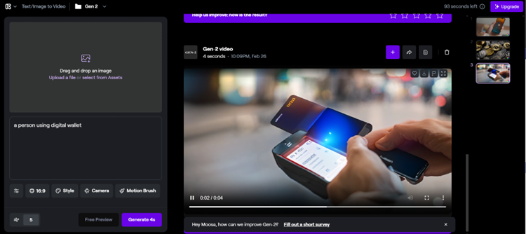

Narration: This correctly shows a person using a phone. But the phone is distorted. Not really a useable video

Review and Rating: I would rate this a **0/5** since this did not give a single useable content. All videos are pretty much live images and very distorted.